**Zomato Analytics - 2024**

**Objective Q&A:**

1. What is the total no. of tables present in the data?- **There are two sheets provided “Raw data” and “Country Description” and the sheets contain one table each**

**Explanation: I have retained the “Raw Data” and “Country Description” sheets as it is and created a New worksheet named “Cleansed Data” and performed all the calculations and cleansing in the same**

1. What is the total no. of attributes present in the data?- **20 Columns in the raw data**

**Explanation: I have considered Restaurant Name, City, Cuisines, Currency, Has_Table_booking, Has_Online_delivery, Price range, Average_Cost_for_two, Rating, Date_key_Opening to perform all the required analysis**

1. How many categorical columns are there in the data?- **There are 13 discrete categorical columns present in the data**

**Explanation: When a particular column can be shown in visual representation, it is called as “Categorical data”**

1. The data consists of some inconsistent and missing values so ensure that the data used for further analysis is cleaned- **Missing values in Column F is cleaned using formula and entered in “Column G“ (Cuisines with formula) in the Cleansed data**

**Explanation: All the blank rows in the Column Cuisine (“Column F”) is from the Country USA and the most repeated cuisine is “American”. Hence I have performed calculation for the same using “Mode” and entered the cuisine in “Column G”**

**Column H “Cuisines” refers to the consolidated cuisines from different countries**

1. Using the LookUp functions, fill up the countries in the original data using the country code- **Refer “Column D” in the Cleansed data**

**Note: I have highlighted the Lookup function in “Column D”- Cleansed data worksheet**

**Explanation: I have used VLookup to perform the calculation and combine Country code with Country in the “Country description” sheet**

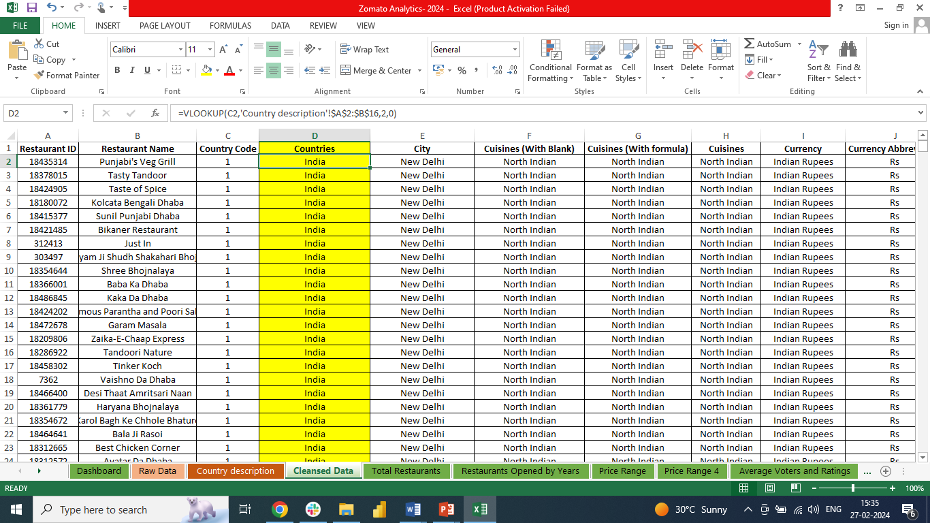

1. Create a table to represent the number of restaurants opened in each country- **I have created separate Tab named “Total Restaurants” in the Excel**

**Explanation: Please refer to the same where I have created a Pivot table to justify this point**



1. Also, the management wants to look at the number of restaurants opened each year, so provide them with something here- **Refer “Restaurants Opened by Years” Tab in the Excel**

**Explanation: I have created Pivot table and a chart to represent the same**

1. What is the total number of restaurants in India in the price range of 4?- **388**

**Note: I have created Tab named “Price Range 4” where I have shown Pivot Table to justify this point. Please refer to the same**



1. What is the average number of voters for the restaurants in each country according to the data?- **I have created Tab named “Average Voters and Ratings” in the Excel with Pivot and Chart. Please refer to the same**



1. Calculate the average rating for all the restaurants that have price_range < 4 and provide online delivery. Use only the “IF” function, Logical Operators, and Aggregation functions to solve this problem. [Note: Don’t use Conditional aggregation in this question.]- **The output is 3.27**

**Explanation: I have created a Tab named** “**Average Voters and Ratings” in the Excel. I have used IF, AND & Average to Justify this point and showed using formula**

1. Using Conditional formatting highlight the rows of restaurants that are located in the countries or cities that you’ve suggested to the management for opening new restaurants-

**Nirula's, Los Agaves, Nosh Mahal, Troll Tavern, Frick's Tap, Consort Restaurant, Star Buffet, Pepe's Piri Piri, Chez Michou, Cantinho da Gula, Damascena Coffee House**

**Note: All these restaurants are highlighted using conditional formatting. Please refer “Column B” of Cleansed Data**

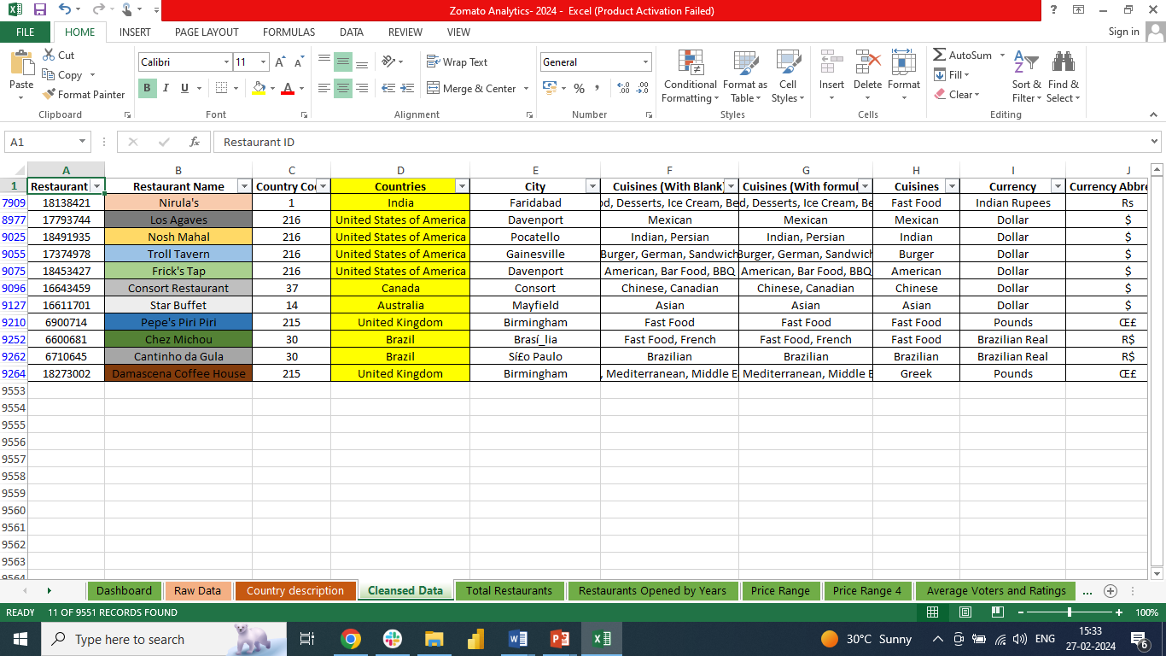

1. Create a new customized price column that consists of the abbreviation/symbol of the currency along with the Average_cost_for_two value. [Use string operations to do this task]- **Refer “Column Q” of the Cleansed data**

**Note: Used Concatenate to combine abbreviation and currency together and the same has been highlighted in “Column Q”**

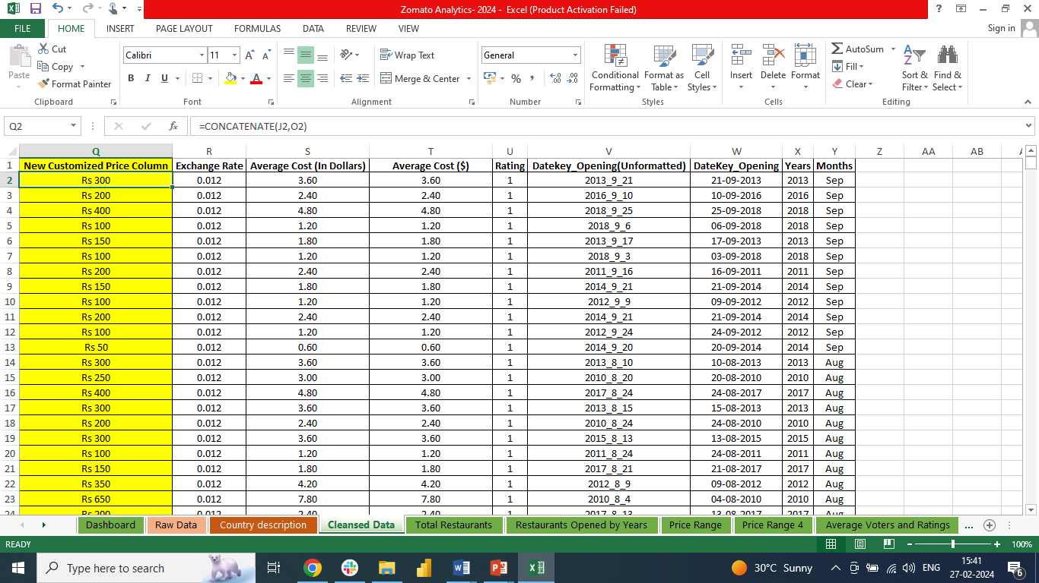

1. How can you create an array formula in Excel or Google Sheets to count the number of restaurants listed that do not offer online delivery, are in the lowest price range, and have an average cost for two people less than or equal to 250 Indian Rupees?- **1685 is the Output**

**Note: I have created a separate** **“Column P” in the Cleansed Data and the same is highlighted for your reference**

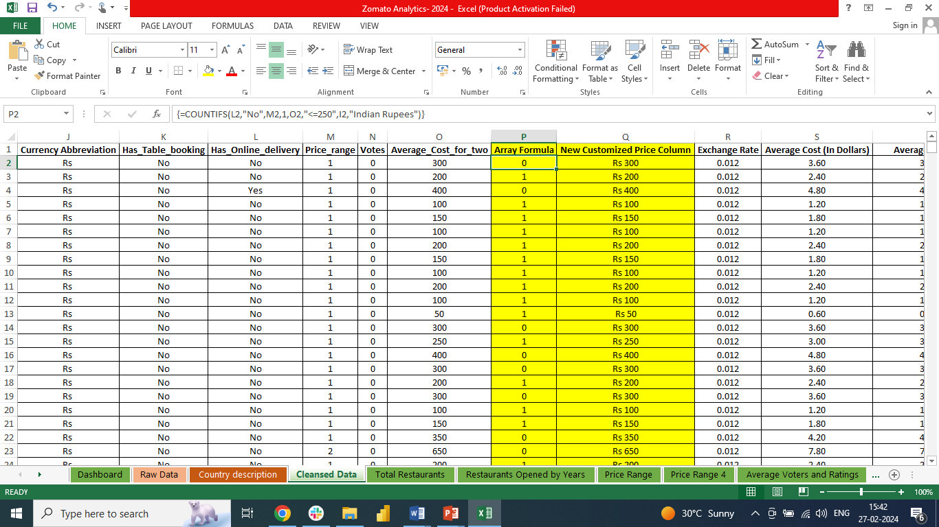

**Subjective Q&A:**

1. Suggest a few countries where the team can open newer restaurants with lesser competition. Which visualization/technique will you use here to justify the suggestions?- **Australia, Brazil, Canada, India, UK, USA**

**Reasons to recommend these countries: The restaurants in these countries doesn’t have Online delivery and Table booking (Refer “Table & Online Booking” Tab in the Excel)**

**Price Range 1 and 2 (Refer “Price Range” Tab in the Excel)**

**Average Cost for Two (in Dollars) >= $11 (Refer “Price Range” Tab in the Excel)**

**Ratings <= 3 (Refer “Average Voters and Ratings” Tab in the Excel)**

**Note: I have converted all the currencies of different countries to USD (Common Currency) for analysis**

1. Come up with the names of States and cities in the suggested countries suitable for opening restaurants- **Suggested Cities are Birmingham, Brasilia, Consort, Davenport, Faridabad, Gainesville, Gurgaon, Mayfield, Pocatello, Silo Paulo**

**Reason: All these States doesn’t have Online delivery and Table booking**

**Price Range 1 and 2**

**Average Cost for Two (in Dollars) >= $11**

**Ratings <= 3**



1. According to the countries you suggested, what is the current quality regarding ratings for restaurants that are open there?- **Average rating of the countries suggested is 2.8 (Refer “Average Voters and Ratings” Tab in the Excel**
2. Also, what is the current expenditure on food in the suggested countries, so we can keep our financial expenditure in control?- **US$ 9 is the Average cost for two (In dollars) on food in the suggested countries (Refer “Average Voters and Ratings” Tab in the Excel)**
3. Come up with the names of restaurants from the recommended states that are our biggest competitors and also those that are rated in the lower brackets, i.e. 1-2 or 2-3- **Nirula's, Los Agaves (the average rating of 2 restaurants opened in the city is 2.55), Nosh Mahal, Troll Tavern, Frick's Tap, Consort Restaurant, Star Buffet, Pepe's Piri Piri, Chez Michou, Cantinho da Gula, Damascena Coffee House**

**Reason: All these restaurants have very less ratings. Hence, when a new restaurant is launched there is very high chances for Zomato to be at the top**

**Note: I have highlighted all the restaurants in “Column B” of the Cleansed Data**



1. Which cuisines should we focus on in the newer restaurants to get better feedback? Does the choice of cuisines affect the restaurant ratings?- **We should focus more on the Asian, Biryani, Café, Contintental, Finger Food, Mexican, North Indian**

**Reason: The suggested countries that has Online delivery, Table Booking and has higher ratings serves all these cuisines**

1. According to our current data, should we go for online delivery and table booking? Does that affect the customer’s ratings?- **Yes, we should provide both as it highly affect the customer’s ratings (Refer “Table & Online Booking” Tab in the Excel**

1. Should the team keep the rate of cuisines higher? Will that affect the feedback? According to our data are the rates of cuisines and ratings, correlated?- **Cost of the cuisine doesn’t affect the rating as per the given data. Hence, we can keep the rates of cuisines higher (Refer “Popular Cuisines” Tab in the Excel)**
2. What is the distribution of the number of restaurants of different price ranges in all the countries?- **1:2:3:4 is 4,444:3,113:1,408:586 (Price range vs Number of restaurants- Refer “Price Range” Tab in the Excel)**
3. Explain your approach in brief for suggesting countries/cities in order to open new restaurants, if the objective and subjective questions would have been given to assist you. [you have to give bullet pointers in order to answer this question]

* **What is the number of restaurants in each location?**
* **How many restaurants have book table facility and how many don’t?**
* **How many restaurants have online order facility and how many don’t?**
* **How much is the average rating restaurants with book table facility got?**
* **How much is the average rating restaurants with online order facility got?**
* **How many different categories of restaurants are present in different locations?**
* **In which locations people prefer to give feedback/vote?**
* **Which category of restaurants are comparatively more expensive or cheaper?**
* **Average cost of cuisines in different locations?**
* **Which cuisines have the most positive ratings?**